**Creating a New Flag: A Symbol of Belonging for a Shared Ireland**

A Symbol of Inclusion, Parity of Esteem, and Shared Governance

### ****Why a New Flag?****

**Executive Summary**

### Ireland’s history is shaped by diverse traditions and national identities. Moving forward requires a flag that represents all communities equally—British, Irish, and Northern Irish—without symbolizing a victory for one tradition over another. More than symbolic, this flag embodies a constitutional commitment to mutual respect, fairness, and equal representation.

**Flags of Division**

The Good Friday Agreement reminds us of the importance of such symbolism:  
  
“All participants acknowledge the sensitivity of the use of symbols and emblems for public purposes, and the need in particular in creating the new institutions to ensure that such symbols and emblems are used in a manner which promotes mutual respect rather than division.”

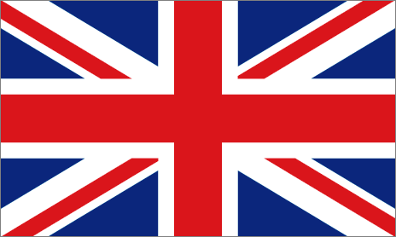

* The Union Flag – Represents British and Unionist identity in Northern Ireland. While many see it as a symbol of sovereignty, others view it as a legacy of division. The new design does not erase it but acknowledges its significance.

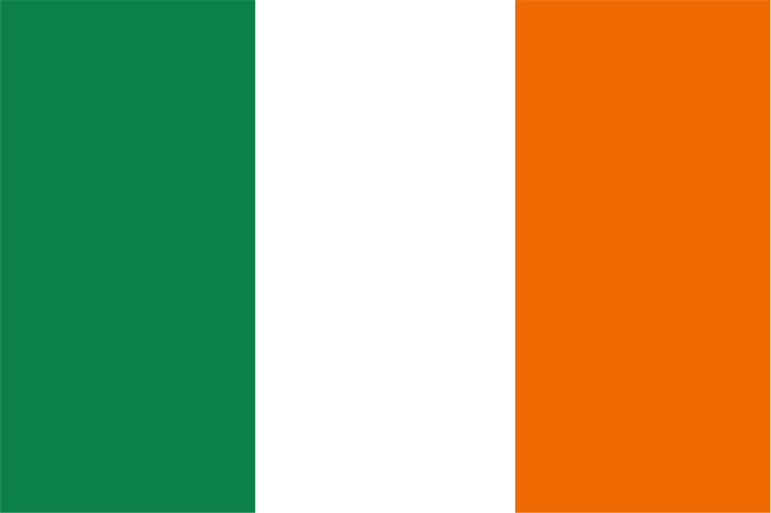

* The Irish Tricolour – Originally intended to represent peace between traditions, it has come to symbolise the Irish and Nationalist identity, both north and south. Despite its deep meaning to many, it remains rejected by many Unionists and thus cannot function as a truly inclusive flag.

In that spirit, we must reflect not only on the national flags of our past and present, but also on the symbolic emblems that have shaped our island’s identity. Each one carries meaning—yet none, alone, can represent us all.

### Symbols That Proceed Division

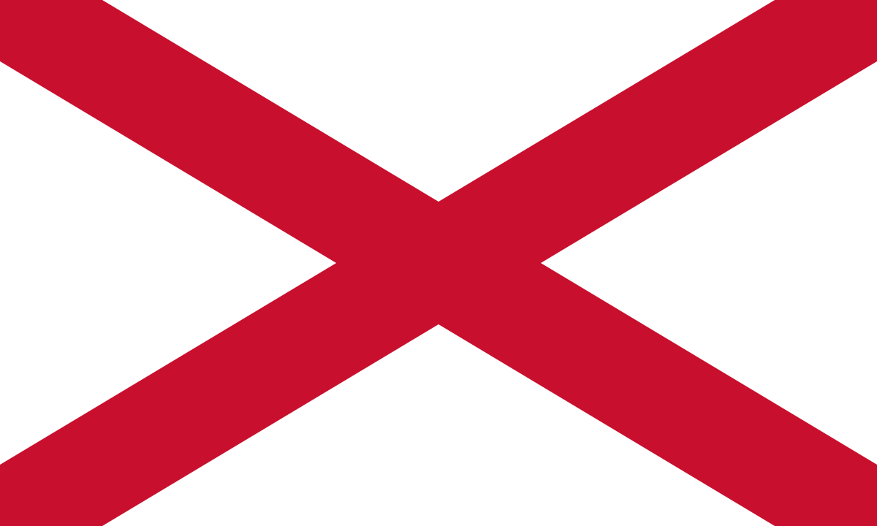

* St. Patrick’s Saltire – A historic Irish-British emblem rooted in the Fitzgerald family and still used in Downpatrick during St. Patrick’s Day. Its presence is not political, but a bridge across traditions—anchored in shared history.

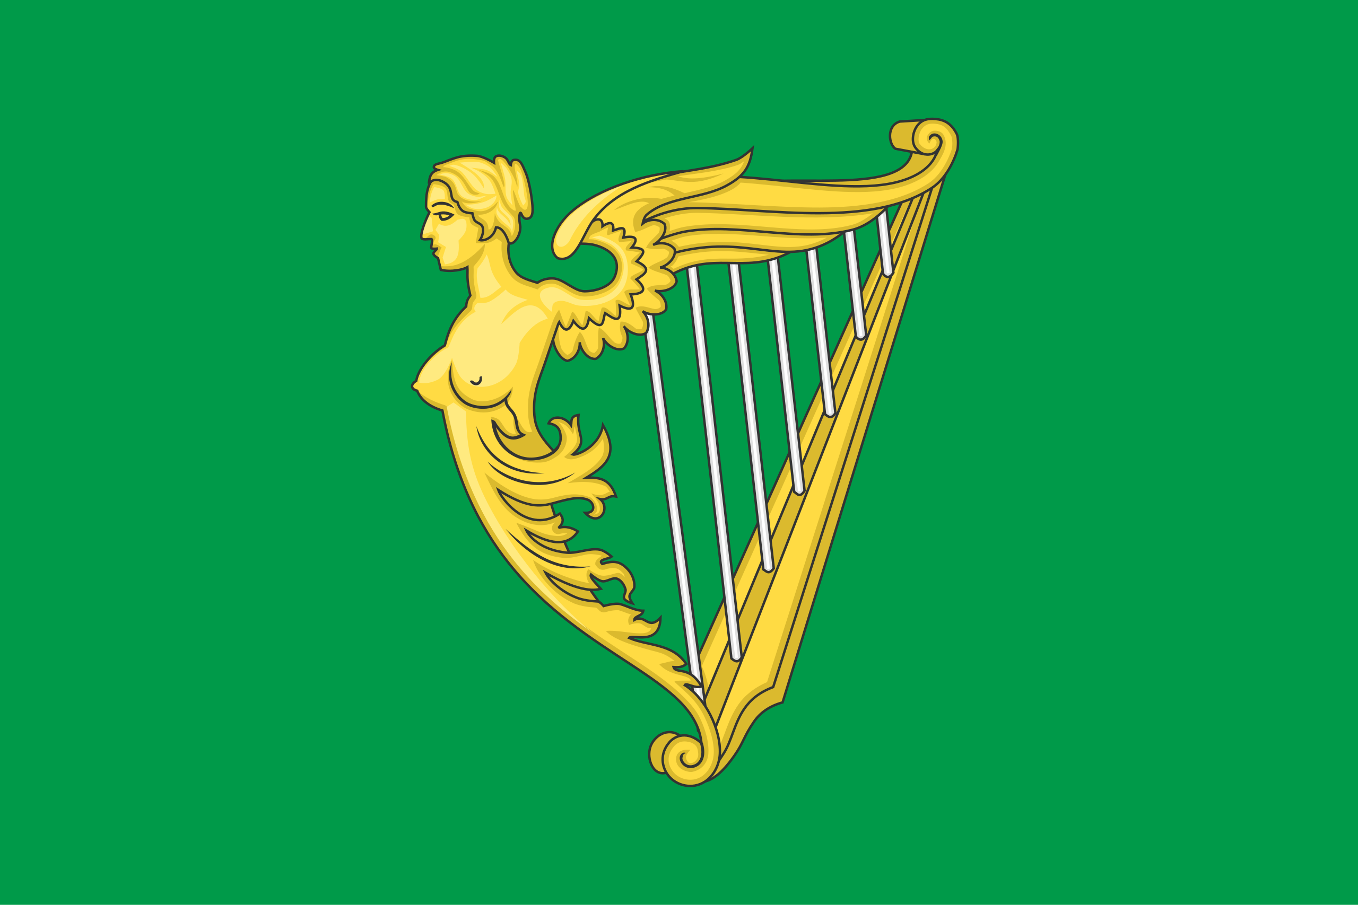

* The Green Harp Flag – A foundational emblem of Irish identity. Historically flown by Protestant, Catholic, and Dissenter alike, it predates the Tricolour. In this flag, it returns as a quiet constant—no longer political, but a symbol of shared environment, heritage, and belonging.

This new flag does not replace these traditions—it gathers them. Each is a thread in a design woven for a shared future. As the journey continues, the next page turns to the Crown—representing loyalty and shared constitutional structure within a reconciled Ireland. This insight helps transition us into the broader framework of a shared Ireland.

**From Shared Heritage to Global Insight**

While Ireland’s path is unique, the challenge of reconciling divided histories through shared symbolism is not. Around the world, post-conflict nations have turned to new flags—not to erase the past, but to build bridges across it. Symbols like the Saltire and Green Harp remind us that identity can evolve—not through erasure, but through reinterpretation. When integrated into a new design, they carry both memory and aspiration.

### ****Lessons from the South African Flag****

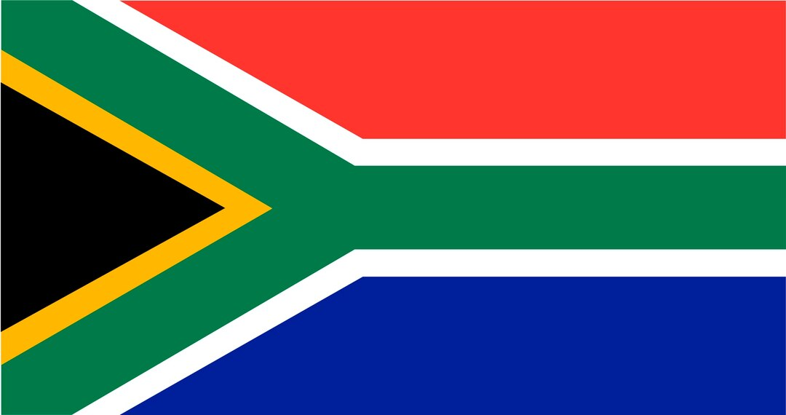

* The South African Flag – Introduced after apartheid, it became a powerful emblem of shared identity. It demonstrates how a nation can unite behind a symbol that respects all traditions. Ireland’s proposed flag follows this principle—offering an emblem of inclusion, reconciliation, and collective future.

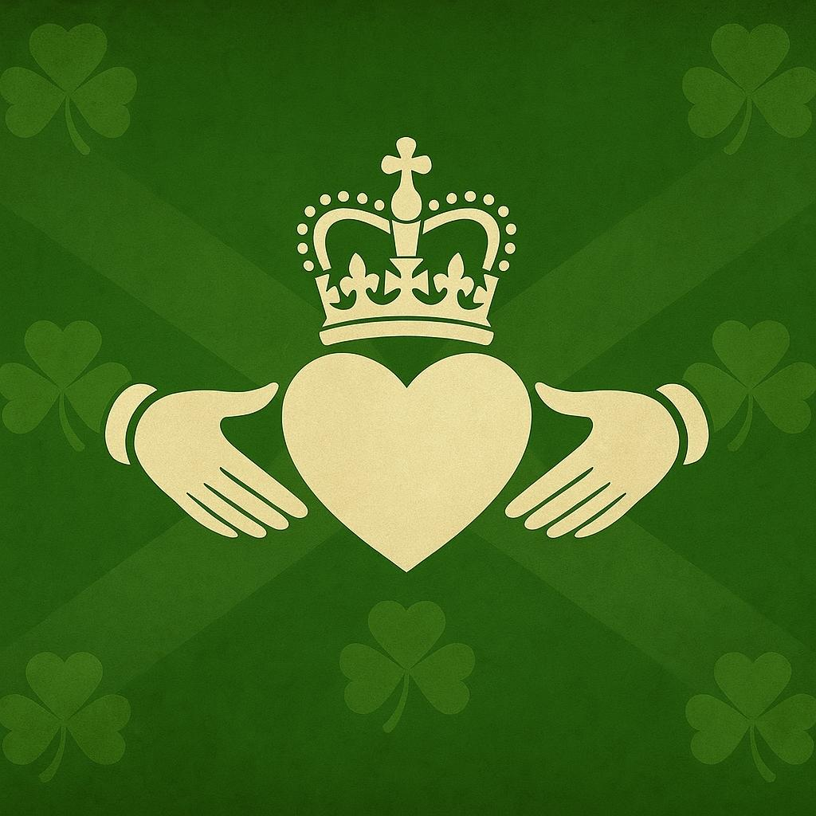

**The Claddagh Ring: A Symbol Reimagined**

The Claddagh Ring carries three timeless elements:

* The **crown**
* The **heart**
* The **clasped hands**

Beyond heritage, the Claddagh reflects the values required for a new future. Rooted in tradition but reaching forward, it becomes a map—a guide for building a shared Ireland grounded in loyalty, love, and friendship.

Though born in Galway, the Claddagh was worn by Queen Victoria and exchanged within the British royal family—proof that its values are not exclusive. This cross-traditional recognition strengthens its constitutional relevance as a symbol of neutrality, inclusion, and shared responsibility.

This vision leads to the opening of The Green Envelope—where the principles of shared governance, balanced representation, and structured inclusion become essential in transforming aspiration into a living constitutional reality.



**Revealing the Flag**

The final flag remains intentionally undisclosed for now—symbolised by a blank canvas. This pause invites reflection. It symbolises openness, imagination, and the shared space where all traditions are invited to see themselves in Ireland’s future.

**A Flag of Belonging**

* Acceptance is essential – The Tricolour was meant to symbolise peace, but is rejected by many Unionists.
* Symbols must reinforce governance – This flag supports a shared governance model where all identities are structurally represented.
* Not a replacement, but a bridge – The Union Flag and Tricolour remain part of Ireland’s legacy. But a new Ireland requires a new emblem—one that belongs equally to all.
* Symbols should reinforce governance, not division – This flag aligns with a shared governance model, ensuring all identities have structured representation.
* A flag for belonging, not replacement – The Tricolour and Union Flag remain part of Ireland’s past and present, but a shared Ireland needs a symbol that represents all identities equally.
* Perfect—thanks for the clarification. What you need is a **single conclusive paragraph** that bridges the **bullet points under “A Flag of Belonging”** to the next section:  
  **“Transitioning to the Structure Behind the Symbol.”**
* Here’s a clean and powerful transition paragraph to insert between the two:

**This flag does not overwrite the past—it builds from it. By honoring both traditions while pointing toward a shared constitutional future, it becomes more than a gesture. It becomes a structural statement.**

### ****Transitioning to the Structure Behind the Symbol****

This flag bridges traditions by upholding **Parity of Esteem** and respecting **British, Irish, and Northern Irish identities**. Rather than replacing existing emblems, it invites all communities to co-author a shared future.

Its design is not just symbolic—it is constitutional.

What follows is not decoration, but **design logic**. A visual expression of shared sovereignty, structured balance, and constitutional parity.

Turn the page, and you will see:  
**The Flag – Structure, Meaning, and Constitutional Parity.**